UNIT 1
UNIT I STORAGE SYSTEMS
Introduction to Information Storage: Digital data and its types - Information storage - Key characteristics of data centre and Evolution of computing platforms. Information Lifecycle Management. Third Platform Technologies: Cloud computing and its essential characteristics - Cloud services and cloud deployment models - Big data analytics - Social networking and mobile computing - Characteristics of third platform infrastructure and Imperatives for third platform transformation. Data Center Environment: Building blocks of a data center - Compute systems and compute virtualization and Software-defined data center.

This unit introduces the fundamentals of information storage and explains how digital data is generated, stored, and managed throughout its lifecycle
Information Storage is the process of recording, organizing, protecting, and managing digital data so that it can be accessed whenever required.
Modern organizations such as banks, hospitals, educational institutions, and e-commerce companies generate huge amounts of data every day. This data must be stored efficiently to ensure availability, security, and reliability
Objectives of Information Storage
Store data securely
Retrieve data quickly
Protect against data loss
Share data among multiple users
Ensure business continuity during failures
1. Digital Data and its Types
Digital data is information converted into a binary format (strings of 0s and 1s) so it can be processed, stored, and transmitted by computers.
Examples:
Documents, Images, Audio files, Videos, Databases, Emails.
Digital data is generally categorized into three primary types based on its organization:
Structured Data: Highly organized data that fits neatly into rows and columns, such as relational databases or spreadsheets. It is easily searchable and managed by Database Management Systems (DBMS).
Examples:
Student records, Employee database, Banking transactions
Stored in:
Relational Database Management Systems (RDBMS)
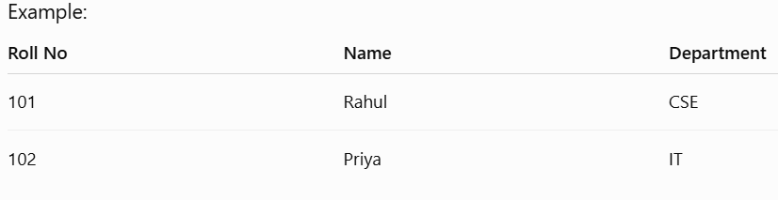

Semi-Structured Data: Information that does not fit into a rigid relational database but contains tags or markers to enforce hierarchies (e.g., JSON and XML files).
Examples:
XML files , JSON files , Emails
JSON and XML are two popular file formats used to store and exchange data between computers, applications, and servers.
1. JSON (JavaScript Object Notation)
JSON is a lightweight, text-based data format that is easy for humans to read and for computers to process. It stores data as key–value pairs.
Example: Student Information (JSON)
{
"Student ID": 101,
"Name": "Haritha",
"Department": "IT",
"Year": 3,
"CGPA": 8.7
}

Features of JSON
- Lightweight and compact.
- Easy to read and write.
- Uses curly braces {} and square brackets [].
- Widely used in web applications, REST APIs, and mobile apps.
- Faster to parse than XML.
Advantage
- Less storage space.
- Faster data transfer.
- Easy to understand.
2. XML (eXtensible Markup Language)
XML is a markup language used to store and transport data. It uses custom tags to describe the data.
XML is a tag-based markup language used to represent structured data. It is more verbose but is well suited for complex documents and configurations.
<Student>
<StudentID>101</StudentID>
<Name>Haritha</Name>
<Department>IT</Department>
<Year>3</Year>
<CGPA>8.7</CGPA>
</Student>

Features of XML
- Uses opening and closing tags.
- Self-descriptive.
- Supports attributes and nested elements.
- Commonly used for configuration files, document storage, and data exchange.

Advantages
- Highly structured.
- Easy to validate using schemas (DTD/XSD).
- Suitable for complex data.
Unstructured Data: Data that has no predefined format, making it harder to search and analyze. Examples include emails, audio/video files, social media posts, and documents.
Examples
Images, Videos, Audio, Social media posts, PDF files
Approximately 80% of enterprise data is unstructured.
3. Information Storage
Information storage refers to storing data on physical or virtual storage devices.

Components of Information Storage
1. Host
Computer or server that generates and accesses data.
Examples
Laptop, Desktop, Server

2. Connectivity
Medium through which data travels.
Examples
Ethernet, Fibre Channel, Wi-Fi, iSCSI

3. Storage Device
Stores data permanently.
Examples
Hard Disk Drive (HDD), Solid State Drive (SSD), Tape, Optical Disk

4. Storage Array
A collection of multiple storage disks managed as a single unit.
Benefits
Higher capacity, Faster performance, Fault tolerance

INFORMATION STORAGE ARCHITECTURES

Digital storage is typically classified by how the data is stored and retrieved. The three core storage architectures are:

Block Storage: Breaks data into uniformly sized "blocks," each with its own address, and stores them independently. It is highly efficient for heavy workloads like databases and Virtual Machines (VMs).

File Storage: Organizes data hierarchically into files and folders, similar to traditional filing cabinets. It is best suited for general-purpose sharing and user-accessible environments.

Object Storage: Stores data as self-contained "objects" bundled with metadata and a unique identifier. It excels at managing massive, ever-growing pools of unstructured data in the cloud

2. Key Characteristics of a Data Center
A data center is a centralized facility housing IT infrastructure (servers, storage, and networking) that collects, processes, and distributes data. The critical characteristics of a modern data center include:

High Availability & Reliability: Redundant power supplies (UPS and backup generators) and cooling systems ensure mission-critical applications run continuously without downtime.

On-Demand Scalability: The ability to rapidly increase or decrease computing and storage resources as business demands fluctuate.

Robust Security: Comprehensive physical security (e.g., biometric access, surveillance) and network security (e.g., firewalls, encryption) to protect sensitive data from cyber threats and physical breaches.

Virtualization & Orchestrated Management: Utilization of software-defined resources to automate workflows, optimize resource pooling, and simplify infrastructure management.

(Characteristics)
1. Availability
The ability of systems to remain operational continuously.
Example
Online banking should be available 24×7. High Availability (HA)
99.999% availability is called Five Nines Availability.

2. Reliability
Ability of the system to perform without failure over time.
Example
A storage server should operate continuously without crashing.

3. Scalability
Ability to increase resources as demand grows.
Example
Adding more storage disks without stopping the system.

4. Performance
Measures how quickly the system responds.
Measured using
- IOPS (Input/Output Operations Per Second)
- Throughput
- Response Time
- Latency

5. Security
Protects stored data from unauthorized access. Includes
- Encryption
- Authentication
- Firewalls
- Access Control

6. Manageability
Easy monitoring and maintenance of storage systems.
Tools monitor
- Disk usage
- CPU usage
- Network traffic
- Storage health

7. Disaster Recovery
Ability to recover data after failures.
Methods
- Backup
- Replication
- Recovery Sites

3. THE EVOLUTION OF COMPUTING PLATFORMS
- Mainframe Era (1950s–1970s): Massive, centralized computers (like the IBM 360) utilized vacuum tubes and later transistors. Processing was batched, and access was limited to specialized operators and large institutions.
Characteristics
  - Large computers
  - Centralized processing
  - Many users share one system

- Minicomputer Era (1960s–1980s): The invention of the microprocessor allowed computers to shrink. Systems like the DEC PDP-11 brought interactive computing to smaller businesses and universities, decentralizing the hardware

- Personal Computer Era (1970s–1990s): The microprocessor revolutionized technology by putting computing power directly into the hands of individuals. This era was dominated by hardware companies like Apple and Microsoft, shifting the focus to Graphical User Interfaces (GUIs) and consumer software.
Characteristics
- Individual computers
- Desktop-based applications

Architecture
- Client → Server
- Example - Browser sends request → Server processes → Response returned
- Internet & Web Era (1990s–2000s): The World Wide Web turned personal computers into nodes on a global network. Information access became the primary platform. Companies like Google and later social media giants emerged as the new computing leaders by organizing and connecting online data.
Features
  - Web applications
  - Global connectivity
  - Online services

- Mobile Computing Era (2000s–2010s): Smartphones and tablets transformed technology from stationary desktops to portable, on-the-go tools with touch interfaces and app ecosystems. Computing became a constant, personal extension of daily life.

- Cloud & AI Era (2010s–Present): Computing shifted from local hardware to virtualized, on-demand services over the internet. Platforms are now driven by massive infrastructures via Amazon Web Services (AWS), Google Cloud Platform, and Microsoft Azure. The current paradigm focuses heavily on Artificial Intelligence (AI), SaaS applications, and intelligent edge devices.
Applications run in cloud data centers instead of local computers.
Examples
- Google Drive
- Microsoft OneDrive
- AWS

4. INFORMATION LIFECYCLE MANAGEMENT?

1. Data creation and capture
The information lifecycle begins the moment data is created or ingested into the organization’s systems. The data could be an application log, a customer transaction, an IoT sensor reading — essentially, any digital record your business generates.

At this early stage, each data point should be classified and tagged by type, source, or sensitivity level. This classification often involves assigning metadata, which describes the data and its characteristics, enabling automated management.

Why it matters: Accurate classification is the foundation for everything that follows. It determines where data is stored, who can access it, and how long it’s kept. Early mistakes here can lead to costly compliance gaps or security risks later on.

2. Data storage and access
Once data is created and classified, it needs to be stored in the right place. This isn’t just about dumping everything on a server — it’s about making smart choices based on:

Access frequency: How often the data needs to be retrieved. Frequently accessed “hot” data belongs in high-performance storage for fast access, while infrequently used “warm” or “cold” data can be stored on lower-cost, lower-performance systems.

Business criticality: Even data that is rarely accessed, such as disaster recovery backups or critical system configurations, may require highly resilient and secure storage because of its importance to operations.

Sensitivity: Highly confidential or regulated data may require encrypted storage, restricted access, or even geographical controls to meet security and compliance requirements.

A tiered storage strategy ensures you get the performance you need for key workloads, while keeping storage costs under control.

3. Data usage and analytics
This stage is where data delivers its real value. It powers operational dashboards, security monitoring, compliance reporting, business intelligence, and even the training of AI and machine learning models — and more. During this phase, data is actively processed, analyzed, and transformed to extract insights and support decision-making.

Key point: Data governance policies are crucial at this stage to ensure data quality, integrity, and ethical use. As usage patterns change — for example, if “cold” data becomes valuable again — you may need to reclassify and move it to higher-performance storage.

However, data’s value isn’t static. Newer data is usually most relevant and delivers the most value. As older data decays, this signals it’s time to prepare it for archiving. Data can also be enriched through integration with other datasets or through various data processing techniques, potentially increasing its value over time.

Tracking how data is used helps you refine future data management and ensures ILM policies stay aligned with real business needs.

4. Data archiving and retention
Eventually, most data becomes less relevant to day-to-day operations but can’t be deleted right away. This is where archiving and retention policies come into play.

Retention periods can vary widely:

Short-term retention: Some records, like certain personal data or financial transactions, must be deleted after a set period for privacy compliance.

Long-term retention: Other records — audit logs, medical data, or tax information — must be kept for years or even decades.

Archived data is typically moved to low-cost, long-term storage. Having clear, documented retention policies helps you avoid accidental loss, fulfill regulatory obligations, and prepare for safe disposal at the right time. This stage often requires coordination between IT, legal, compliance, and business stakeholders.

5. Data disposal and deletion
All data reaches the end of its useful life. Whether driven by business need or regulatory mandate, disposal must be thorough and secure.

But disposal is more than simply deleting files. It must follow strict, verifiable processes to ensure data is permanently removed and can’t be recovered. This often involves:

Secure wiping or encryption-based deletion for digital data.
Physical destruction of storage media when appropriate.
Audit trails or certificates of destruction to demonstrate compliance.

Why this matters: Secure disposal minimizes your risk of data breaches, reduces exposure to regulatory penalties, and keeps your storage footprint in check. Maintaining audit trails or certificates of destruction is essential for compliance and peace of mind.

INTRODUCTION TO THIRD PLATFORM TECHNOLOGIES
What is a Platform?

A computing platform is the combination of hardware, software, storage, networking, and operating systems used to develop and run applications.

As technology evolved, computing platforms also changed to meet business requirements.

What is the Third Platform?
The Third Platform refers to modern digital technologies that enable organizations to deliver services over the internet with high speed, scalability, and flexibility.

The Third Platform consists of four major technologies:
- Cloud Computing
- Mobile Computing
- Big Data Analytics
- Social Networking
These technologies work together to support digital transformation.
Example
When you book a cab using Uber:

Mobile phone → Mobile Computing
Maps and ride booking → Cloud Computing
Customer travel analysis → Big Data Analytics
Sharing your ride on social media → Social Networking

Thus, one application uses all Third Platform technologies.

2. Why Was Cloud Computing Introduced?
Imagine a college wants to store student records.

Traditional Method
The college purchases:
Servers
Hard disks
Networking equipment
UPS
Air conditioning
Software licenses
IT staff

This requires:
High investment, Regular maintenance, Physical space, Electricity

Cloud Method
Instead of purchasing servers, the college rents storage and computing resources from a cloud provider.
Advantages:
Lower cost, No hardware maintenance, Easy access, Automatic backup, Scalable resources

3. What is Cloud Computing?
Definition
Cloud Computing is a technology that provides computing resources such as servers, storage, databases, networking, software, and applications over the Internet on demand.

Users pay only for the resources they use.

Simple Definition:

Cloud Computing means using someone else's computer over the Internet instead of owning your own computer infrastructure.

5. Everyday Examples of Cloud Computing
Google Drive
Store files online.
Instead of saving files on your laptop:
Laptop ❌
Google Drive ✔
Files can be accessed from anywhere.

Gmail
Emails are stored in Google's cloud servers.
You can log in from:
Mobile, Laptop,Tablet
Your emails remain available.

Netflix
Movies are stored in cloud servers.
Users simply stream movies without downloading everything.

Microsoft OneDrive
Stores:
Word documents
Excel sheets
PowerPoint presentations

WhatsApp
Photos and chats are backed up to cloud storage.
College ERP
Students access:
Attendance, Internal marks, Fee details
through cloud-based applications.

7. Essential Characteristics of cloud computing
According to the National Institute of Standards and Technology (NIST), cloud computing has five essential characteristics.

Characteristic 1 – On-Demand Self-Service

Definition
Users can obtain computing resources automatically whenever needed without contacting the service provider.

Example
A software company requires:
- One virtual server
Instead of calling an engineer,
The administrator simply logs into AWS or Azure and creates a virtual machine within minutes.
No human interaction is required.

Real-Life Example
Booking a movie ticket online.
You select:
- Movie
- Seats
The booking is completed instantly.
Similarly,
Cloud users create servers instantly.

Benefits
- Fast
- Convenient
- Saves time

Characteristic 2 – Broad Network Access

Definition
Cloud services are available over the Internet and can be accessed using different devices.

Devices
- Laptop
- Mobile phone
- Tablet
- Desktop

Example
A student uploads an assignment from home using a laptop.
The faculty downloads it in college using a desktop.
The principal views it on a mobile phone.
All access the same cloud application.

Real-Life Example
Google Docs
Several people edit one document simultaneously from different locations.

Benefits
- Anywhere access
- Anytime access
- Supports remote work

Characteristic 3 – Resource Pooling

Definition
Cloud providers share computing resources among multiple customers.
This is called the Multi-Tenant Model.

Example
Imagine a hotel.
One building serves hundreds of guests.
Each guest gets a separate room.
Similarly,
Amazon Web Services has one data center serving thousands of customers.
Although they share hardware, each customer's data remains isolated.

Example
AWS Storage
Company A
↓
Company B
↓
Company C
↓
All use the same physical storage system.

Benefits
- Better resource utilization
- Lower cost
- Efficient management

Characteristic 4 – Rapid Elasticity

Definition
Cloud resources can increase or decrease automatically according to demand.

Example
Online Shopping During Diwali
Normally:
1000 users visit the website.
During Diwali:
10 lakh users visit.
Cloud automatically adds:
- Servers
- Storage
- Memory
After the festival,
Resources reduce automatically.

Another Example
College Online Examination
During exams,
Server capacity increases.
After exams,
Extra resources are removed.

Benefits
- Handles sudden traffic
- No performance issues
- Saves money

Characteristic 5 – Measured Service

Definition
Cloud providers monitor resource usage and charge customers based on consumption.
This is called the Pay-As-You-Go Model.

Example
Electricity Bill
You pay only for units consumed.
Similarly,
Cloud users pay only for:
- Storage used
- CPU hours
- Network bandwidth
- Virtual machines

Example
A startup stores:
100 GB
After three months,
It stores:
300 GB
The bill increases only for additional storage.

Benefits
- Cost-effective
- No unnecessary investment
- Transparent billing

ARCHITECTURE OF CLOUD COMPUTING

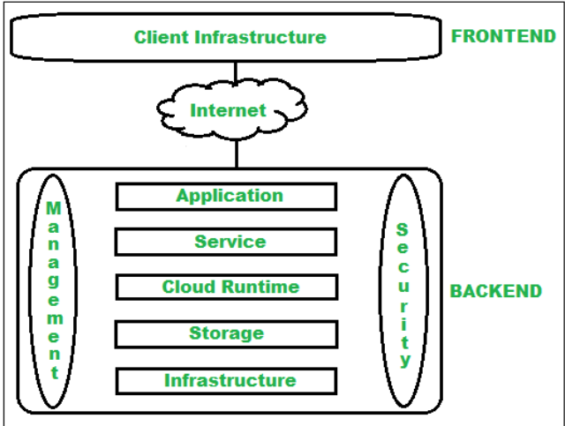

1. The Frontend (Client Side)
The frontend is the visible side of the cloud computing system. It contains all the user interfaces and client infrastructure required for end-users to interact with the cloud.
- Client Infrastructure: The hardware and software components (like a laptop, mobile phone, or web browser) that provide a Graphical User Interface (GUI) to access cloud services.

2. The Backend (Cloud Provider Side)
The backend is the "cloud" itself. Managed by the service provider, it houses the core resources, manages traffic, deploys models, and enforces security.
Component | Description
Application | The actual software or platform the client accesses, running in the backend to fulfill user requests.
Service | Manages the specific type of cloud service being delivered to the user (e.g., SaaS, PaaS, IaaS).
Runtime Cloud | Provides the execution environment for virtual machines. Modern setups often utilize container orchestration platforms like Kubernetes to dynamically manage and scale these runtime workloads.
Storage | Provides flexible, scalable storage for data management (e.g., object storage, block storage).
Infrastructure | The foundational hardware and virtualization software (servers, network devices). Modern environments typically manage this layer using Infrastructure as Code (IaC) to automate provisioning and scaling.
Management | The control plane responsible for allocating resources, monitoring performance, and managing all other backend components.
Security | Implements robust mechanisms (like Identity and Access Management) to secure cloud resources, networks, and data from unauthorized access.
Database | Provides managed environments for storing structured or unstructured data, such as SQL (Amazon RDS) or NoSQL databases.
Networking | The infrastructure that directs traffic, including load balancers, DNS, and Virtual Private Networks (VPNs/VPCs).
Analytics | Built-in capabilities for data warehousing, business intelligence, and machine learning pipelines.

Real-World Applications of Cloud Architecture

Cloud computing has become an essential part of modern business, offering unparalleled flexibility, scalability, and cost-effective solutions. However, to harness its full potential, selecting the most appropriate cloud deployment model is critical. Whether you are a small startup or a massive enterprise, your choice will directly dictate your organization's security, scalability, and operational efficiency
What is a Cloud Deployment Model?
A cloud deployment model defines where your cloud infrastructure lives, who owns and manages it, and how it is accessed. It establishes the boundaries of your cloud environment, dictating what you can customize, how resources are shared among users, and the overarching purpose of the setup.
Understanding these models is the crucial first step for any business migrating to the cloud, as each offers distinct trade-offs in governance, cost, security, and management.

Public Cloud
The public cloud delivers infrastructure and services over the internet to the general public or broad industry groups. The infrastructure is entirely owned, managed, and maintained by a third-party cloud service provider (e.g., Google Cloud, AWS, Microsoft Azure). Resources are shared among multiple tenants.
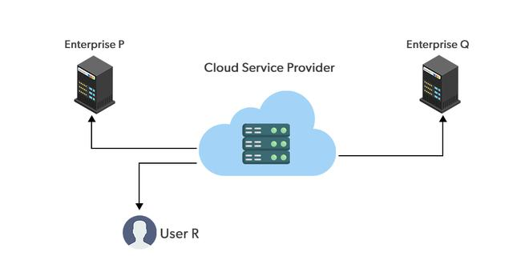Public Cloud

Advantages of the Public Cloud Model
- Minimal Investment: Operates on a pay-per-use model with no substantial upfront capital expenditure.
- Zero Setup & Maintenance: The provider subsidizes and manages all physical hardware setup and ongoing maintenance.
- Dynamic Scalability: On-demand resources are nearly limitless, scaling instantly to fulfill business needs.

Disadvantages of the Public Cloud Model
- Lower Security: Because resources are shared publicly, meeting strict, high-level compliance and security standards can be challenging.
- Low Customization: The standardized environment offers little room for bespoke hardware or infrastructure customizations.

Private Cloud
The private cloud deployment model is the exact opposite of the public cloud deployment model. It's a one-on-one environment for a single user (customer). There is no need to share your hardware with anyone else. The distinction between private and public clouds is in how you handle all of the hardware. It is also called the "internal cloud" & it refers to the ability to access systems and services within a given border or organization. The cloud platform is implemented in a cloud-based secure environment that is protected by powerful firewalls and under the supervision of an organization's IT department. The private cloud gives greater flexibility of control over cloud resources.
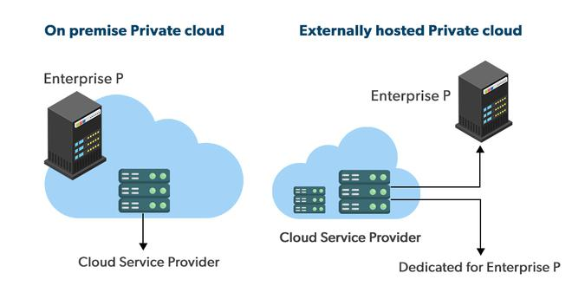
Private Cloud

Advantages of the Private Cloud Model
- Total Control: You have complete command over IT operations, service integration, and user behavior.
- Elite Security and Privacy: Ideal for sensitive corporate data, allowing for strict access controls and physical isolation.
- Legacy System Support: Highly customizable, making it capable of supporting legacy applications that cannot migrate to a public environment.

Disadvantages of the Private Cloud Model
- High Cost: Personalized facilities, dedicated hardware, and internal IT management make this the most expensive option.
- Limited Scalability: Scaling is restricted by the physical capacity of the dedicated hardware purchased.

Hybrid Cloud
By bridging the public and private worlds with a layer of proprietary software, hybrid cloud computing gives the best of both worlds. With a hybrid solution, you may host the app in a safe environment while taking advantage of the public cloud's cost savings. Organizations can move data and applications between different clouds using a combination of two or more cloud deployment methods, depending on their needs.
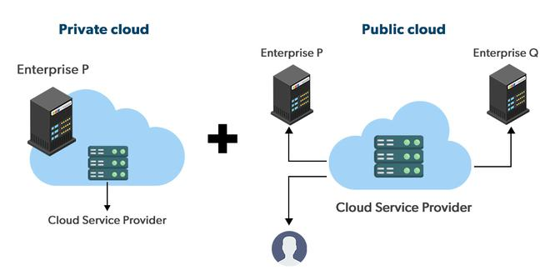Hybrid Cloud

Advantages of the Hybrid Cloud Model
- Ultimate Flexibility: Businesses can keep sensitive data secure on the private cloud while running heavy, non-sensitive applications on the public cloud.
- Cost Efficiency: You only pay for additional public cloud capacity when you experience traffic spikes that your private cloud cannot handle (known as "cloud bursting").
- Targeted Security: Data theft risks are reduced by keeping the most critical assets completely isolated.

Disadvantages of the Hybrid Cloud Model
- Difficult to manage: Hybrid clouds are difficult to manage as it is a combination of both public and private cloud. So, it is complex.
- Slow data transmission: Data transmission in the hybrid cloud takes place through the public cloud so latency occurs.

Community Cloud
A community cloud is a collaborative infrastructure shared by a specific group of organizations from a similar industry that have shared concerns (e.g., compliance, security requirements, or mission goals). It can be managed internally by the organizations or by a third party.
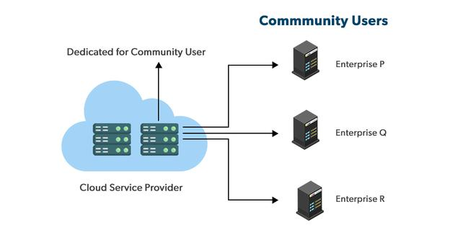
Community Cloud

Advantages of the Community Cloud Model
- Cost Effective: It is cost-effective because the cloud is shared by multiple organizations or communities.
- Security: Community cloud provides better security.
- Shared resources: It allows you to share resources, infrastructure, etc. with multiple organizations.
- Collaboration and data sharing: It is suitable for both collaboration and data sharing.

Disadvantages of the Community Cloud Model
- Limited Scalability: Community cloud is relatively less scalable as many organizations share the same resources according to their collaborative interests.
- Rigid in customization: As the data and resources are shared among different organizations according to their mutual interests if an organization wants some changes according to their needs they cannot do so because it will have an impact on other organizations.

Multi-Cloud
While a hybrid cloud mixes private and public models, a multi-cloud strategy specifically involves using multiple public cloud providers at the same time (e.g., using AWS for storage, Google Cloud for machine learning, and Azure for active directory).
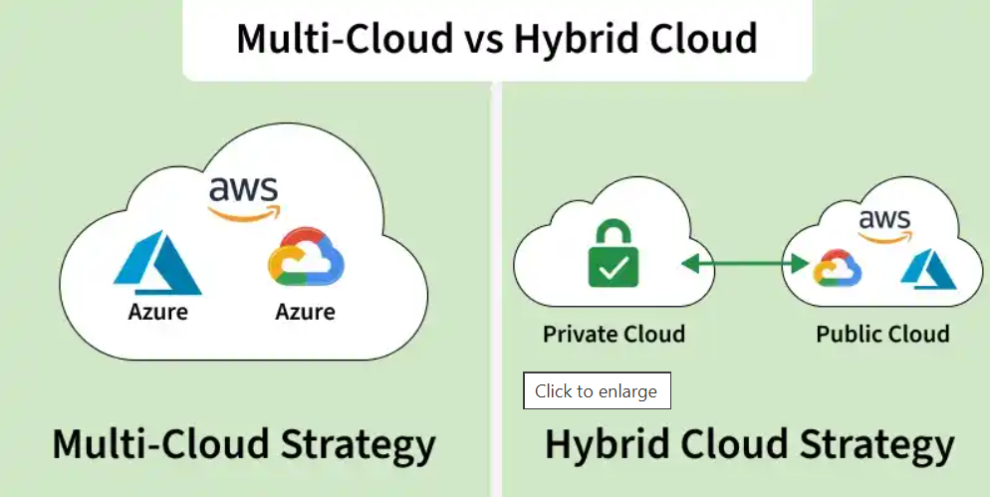

Advantages of the Multi-Cloud Model
- Best-of-Breed Features: You can mix and match the absolute best tools from different providers to suit specific workloads.
- Reduced Latency: You can route user traffic to the cloud provider that has a data center closest to that specific user.
- High Availability: It is incredibly rare for two different major cloud providers to experience outages simultaneously, creating exceptional disaster recovery.

Disadvantages of the Multi-Cloud Model
- Complex: The combination of many clouds makes the system complex and bottlenecks may occur.
- Security issue: Due to the complex structure, there may be loopholes to which a hacker can take advantage hence, makes the data insecure.

How to Choose the Right Deployment Model
There is no one-size-fits-all approach. The ideal choice depends entirely on your specific business requirements. Consider these five factors:
- Cost: Determine your budget for upfront capital expenses versus ongoing operational expenses.
- Scalability: Assess your current traffic and predict how rapidly you will need to scale resources in the future.
- Ease of Use: Evaluate the technical expertise of your internal IT staff and their ability to manage complex infrastructures.
- Compliance: Identify any legal or industry regulations (like HIPAA or GDPR) that dictate where and how your data must be stored.
- Privacy: Classify your data to determine what can be public and what requires strict, isolated confidentiality.

Cloud Deployment Models Comparison
The overall Analysis of these models with respect to different factors is described below.
Factors | Public Cloud | Private Cloud | Community Cloud | Hybrid Cloud
Initial Setup | Easy | Complex, requires a professional team to setup | Complex, requires a professional team to setup | Complex, requires a professional team to setup
Scalability and Flexibility | High | High | Fixed | High
Cost-Comparison | Cost-Effective | Costly | Distributed cost among members | Between public and private cloud
Reliability | Low | Low | High | High
Data Security | Low | High | High | High
Data Privacy | Low | High | High | High

CLOUD SERVICES
Cloud service models describe what type of service a cloud provider offers. There are three primary service models.
1. Infrastructure as a Service (IaaS)
2. Platform as a Service (PaaS)
3. Software as a Service (SaaS)

Service Provided

IaaS | PaaS | SaaS
Virtual Machines (VMs) | Operating System | Email
Storage | Database | Office software
Networking | Middleware | CRM
Firewalls | Runtime Environment | ERP
Load Balancers | Development Tools | Video conferencing

Responsibilities
Cloud provider

IaaS | PaaS | SaaS
• Physical servers  • Storage hardware  • Networking  • Virtualization | • Hardware  • Networking  • Operating System  • Runtime  • Middleware | Everything

Customer

IaaS | PaaS | SaaS
• Operating System  • Applications  • Data  • Security configurations | • Application code  • Application data | Uses the software

1. Infrastructure as a Service (IaaS)
- Definition: Provides virtualized computing resources (servers, storage, and networking) over the internet.
- User Role: Users retain full control over the infrastructure, customizing and managing virtual machines, operating systems, and network configurations.
- Examples: Amazon Web Services (AWS) EC2, Microsoft Azure Virtual Machines.

2. Platform as a Service (PaaS)
- Definition: Provides a ready-to-use platform and environment for developers to build, deploy, and manage applications.
- User Role: Developers focus solely on writing code and managing the application lifecycle, while the provider handles the underlying infrastructure, databases, and middleware.
- Examples: Google App Engine, Heroku

3. Software as a Service (SaaS)
- Definition: Delivers fully developed software applications over the internet on a subscription basis.
- User Role: End-users simply access the application via a web browser or app, eliminating the need for local installation, maintenance, or patching.
- Examples: Salesforce, Google Workspace, Microsoft 365.

Part II: Cloud Deployment Models

Cloud deployment models describe where the cloud infrastructure is deployed and who can access it.

1. Public Cloud
Definition

Infrastructure is owned and managed by a cloud service provider and shared among multiple customers over the internet.

Characteristics
Shared infrastructure
Internet-based access
Pay-as-you-go
Highly scalable

Advantages
Low cost
Easy deployment
High availability
No hardware maintenance

Disadvantages
Less control
Shared resources
Security concerns for sensitive data

Examples
Amazon Web Services (AWS)
Microsoft Azure
Google Cloud

Applications
Web hosting
Mobile applications
Software testing
Startups

2. Private Cloud
Definition
Cloud infrastructure is dedicated to a single organization.

Characteristics
Exclusive resources
High security
Full control
Customized infrastructure

Advantages
Better security
Improved privacy
Greater customization
Regulatory compliance

Disadvantages
Higher cost
Maintenance responsibility

Applications
Banks
Government organizations
Hospitals
Defense

3. Hybrid Cloud
Definition
A combination of public and private clouds that allows data and applications to move between them.

Characteristics
Combines flexibility and security
Sensitive data remains private
Public cloud handles additional demand

Advantages
Cost-effective
High flexibility
Disaster recovery
Scalability

Disadvantages
Complex management
Integration challenges

Applications
E-commerce, Financial services, Educational institutions

Example

A bank stores customer information in a private cloud while hosting its public website on a public cloud.
4. Community Cloud
Definition

Infrastructure shared by multiple organizations with common requirements such as security, compliance, or research.

Characteristics
Shared ownership
Shared cost
Common security policies

Advantages
Cost sharing
Better collaboration
Industry-specific compliance

Disadvantages
Limited scalability
Shared governance

Applications
Universities
Healthcare organizations
Government departments

Example
Several universities share a cloud platform for research data and educational resources.

